Simulation of Corrosion

SYSC-5104 Methodologies for Discrete-Event Modelling and Simulation



Gurveen Kaur (101088497)

Mandeep Singh Bal (101089294)

1. **INTRODUCTION**

Humans had been going through the Progression from last century at rapid Speed. They developed essential and several extraordinary skills with time for problem resolution.. Science gained powerful insights not only about humans, earth but also about the universe which was imagined to be far from reality. It had been advent that in order to invent or learn one has to make several mistakes and experiments to devise something important and unique. Experimentation had been part of our human race for a long time. Successful Invention of the bulb by Thomas Alva Edison involved experimenting approx 3000 different combinations. Although during historic times experimentation was not only tough but also had a good budget.

With the Advancement for experimentation and to achieve a cost-efficient and Safe technique to process the Simulation, Several Software and systems had been made so that the Simulation and experimentation can take place along with exhaustive testing of the products. There are many systems which cannot be released or testing physically due to multiple reasons such as Safety-critical, high cost or un-predictive behavior which can cause hazards as well.

Simulation and Modeling are used in such criteria’s. People use several software to simulate the working of the systems and then carry out the experimentation to check the systems operations. Simulators are used in almost all the major industries Such as Hospitality, Defense, Research, Educational Institutions and Gaming industry etc in order to train the new people, test the new technology and its outcomes which can be unpredictable if tested in real-time and can cause major accidents as well, create new games with better design and to create real-world replica’s of the activities.

The simulation also provides the answers to unsolved questions as well as natural processes. One can try to reproduce the natural process such as corrosion to understand the complete the process. During experimentation stage, one can focus on providing various, conditions or inputs and test how system simulation responds to those.

To achieve the optimum simulation one need to create the best replica of the real-life system/process so that the experimentation also produce the results same produced by systems.

This Paper Focuses on CELL-DEVS (Discrete-Event systems Specifications) formalism for Simulation of the Corrosion process. To Simulate the system using cell-devs the system working/operations needs to broken-down into discrete events which run at a particular time event. The Simulation is carried over time and events which respond to that time are carried out. If complex systems contain several independent components then atomic models can be used which acts as a protected containers designed to provide the specific operations to expected inputs and respond after computation with a output which can be either fed to next atomic model and then output becomes the input or can act as result of coupled model which is a non devisable model which can have multiple atomic models.

If there are multiple coupled models they can be coupled together using Couplings.

New Version of CD++ is used for cell-devs formalism in this paper which offers several new features to provide better performance.

In Cell-Devs, each cell act as the atomic model which receives the input using input port. Once the input is received the local computing function which is followed by the change in state of the cell with the associated delay and message transmission to all neighbor cells. As Cell-devs is the extension of devs we can create an n-dimensional lattice of cells. In Cell-devs we need to create rules for a transition of event successfully which follows VALUE DELAY { CONDITION } Syntax. If the condition satisfies then after the delay the value of the cell changes to the values specified in the rule.

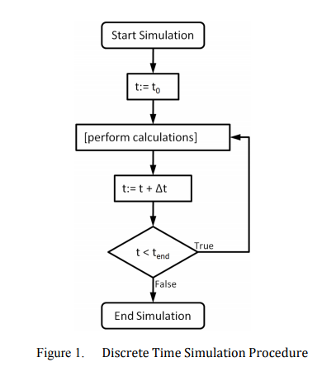

We can use transport or inertial delays as per required function.

In This paper, Simulation and modeling of the corrosion process are shown along with several experiments and comparison with Assignment 2 Corrosion model Simulation times.

Corrosion leads to decrease in strength and converts the metal to its natural form. It takes a series of steps to convert a metal ore to useful metal. Due to corrosion, the metal undergoes oxidation and reduction reactions which lead to metal to lowest possible energy state. Thus it does not only leads to degradation of metal but also adds the cost liability to refine more metal from its ore. This creates a huge loss of money and thus corrosion prevention bills affect each economy a substantial amount.

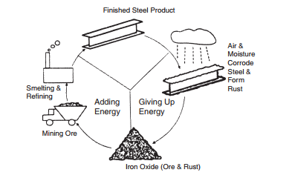

1. **BACKGROUND**

Corrosion is a natural process which leads to deterioration of metal due to reaction to the environment in presence of salts. The corrosion of metal is also known as rust.

When metal surface comes in contact with oxygen and moisture (water/acid).Metal Degradation starts which not only decrease the strength but also reduce the appearance of the metal.

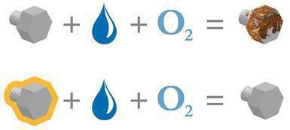

Corrosion can occur in any uniform or non uniform manner.

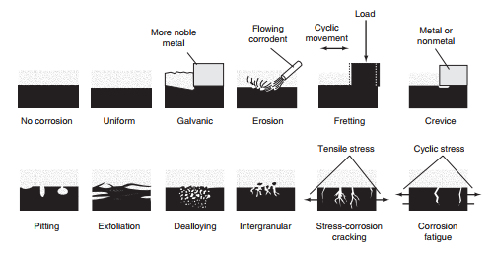

As corrosion starts on exposed surfaces. Metal can be protected by several methods such as Painting, Galvanization, Using Inhibitors, Sacrificial Coatings,

In This paper, we will show the corrosion of metal surface during different experiments which are mentioned below.

1. Metal Surface exposes the environment.
2. Metal Surface with New Paint.
3. Metal Surface with Crack in the Paint.
4. Metal Surface with High Amount of water.
5. Metal Surface with Low Amount of water.
6. Metal surface showing passivation.

Among these experiments, 1 is extensions of the assignment 2 models so we will compare the results among them.

1. **MODELS :-**

**3.1 Metal Surface exposes the environment. (60 Sec)**

Metal Surface fully exposed to environment as per uniform corrosion takes 60 simulation seconds for full corrosion of metal

[top]

components : Rust

in : input1 input2

link : input1 input1@Rust

link : input2 input2@Rust

[Rust]

type : cell

width : 20

height : 20

delay : transport

defaultDelayTime : 1000

border : nowrapped

neighbors : Rust(0,-1) Rust(0,0) Rust(0,1)

neighbors : Rust(-1,-1) Rust(-1,0) Rust(-1,1)

initialvalue : 0.0

initialrowvalue : 0 22222222222222222222

initialrowvalue : 1 22222222222222222222

initialrowvalue : 2 22222222222222222222

initialrowvalue : 3 11111111111111111111

statevariables: water active

StateValues: 2 0.0

in : input1 input2

link : input1 in@Rust(0,0)

link : input2 in@Rust(0,1)

link : input1 in@Rust(0,2)

link : input2 in@Rust(0,3)

link : input1 in@Rust(0,4)

link : input2 in@Rust(0,5)

link : input1 in@Rust(0,6)

link : input2 in@Rust(0,7)

link : input1 in@Rust(0,8)

link : input2 in@Rust(0,9)

link : input1 in@Rust(0,10)

link : input2 in@Rust(0,11)

link : input1 in@Rust(0,12)

link : input2 in@Rust(0,13)

link : input1 in@Rust(0,14)

link : input2 in@Rust(0,15)

link : input1 in@Rust(0,16)

link : input2 in@Rust(0,17)

link : input1 in@Rust(0,18)

link : input2 in@Rust(0,19)

localtransition : Rust-rule

% When the metal gets fully exposed to water molecules

[Rust-rule]

rule : {(-1,0)} 600 {(0,0)=2 and (-1,0)=-5}

rule : { (-1,0) + 719 } 71973 { (0,0) = $active and (-1,0) != ? and 0 < (-1,0) }

rule : { (-1,-1) + 1790 } 179049 { (0,0) = $active and (-1,-1) != ? and 0 < (-1,-1) }

rule : { (-1,1) + 2025 } 202534 { (0,0) = $active and (-1,1) != ? and 0 < (-1,1) }

rule : { (0,-1) + 2532 } 253213 { (0,0) = $active and (0,-1) != ? and 0 < (0,-1) }

rule : { (0,1)+ 2767 } 276711 { (0,0) = $active and (0,1) != ? and 0 < (0,1) }

rule : {(0,0)} 0 { t }

* 1. **Metal Surface with New Paint. (4 Sec)**

In This model Surface Is painted with insulating layer of new paint which protects it from corrosion and thus metal remain protected. This Simulation stop after water reaches the Paint layer coating and runs for 4 Seconds.

[top]

components : Rust10

in : input1 input2

link : input1 input1@Rust10

link : input2 input2@Rust10

[Rust10]

type : cell

width : 20

height : 20

delay : transport

defaultDelayTime : 1000

border : nowrapped

neighbors : Rust(0,-1) Rust(0,0) Rust(0,1)

neighbors : Rust(-1,-1) Rust(-1,0) Rust(-1,1)

initialvalue : 0.0

initialvalue : 0.0

initialrowvalue : 0 99229999922999992299

initialrowvalue : 1 99229999922999992299

initialrowvalue : 2 99229999922999992299

initialrowvalue : 3 77777777777777777777

initialrowvalue : 4 77777777777777777777

initialrowvalue : 5 77000000000000000077

initialrowvalue : 6 77000000000000000077

initialrowvalue : 7 77000000000000000077

initialrowvalue : 8 77000000000000000077

initialrowvalue : 9 77000000000000000077

initialrowvalue : 10 77000000000000000077

initialrowvalue : 11 77000000000000000077

initialrowvalue : 12 77000000000000000077

initialrowvalue : 13 77000000000000000077

initialrowvalue : 14 77000000000000000077

initialrowvalue : 15 77000000000000000077

initialrowvalue : 16 77000000000000000077

initialrowvalue : 17 77000000000000000077

initialrowvalue : 18 77777777777777777777

initialrowvalue : 19 77777777777777777777

StateVariables: water active

StateValues: 2 0.0

in : input1 input2

link : input1 in@Rust10(0,2)

link : input2 in@Rust10(0,3)

link : input1 in@Rust10(0,9)

link : input2 in@Rust10(0,10)

link : input1 in@Rust10(0,16)

link : input2 in@Rust10(0,17)

localtransition : Rust-rule

zone : insulation { (3,0)..(4,19) }

zone : insulation { (5,0)..(17,2) }

zone : insulation { (18,0)..(19,19) }

zone : insulation { (5,18)..(17,19) }

[Rust-rule]

rule : {(-1,0)} 300 {(0,0)=2 and (-1,0)=-5}

rule : {(0,0)} 600 { t }

[insulation]

rule : {(0,0)} 600 {undefCount >= 1}

rule : {(0,0)} 600 {t}

* 1. **Metal Surface with Crack in the Paint (99 Sec)**

This Simulation Provides the best results to observe the corrosion as water flows over the crack in the paint which can be caused due to age or degradation due to environmental factors.When Water flows thorough the crack and as moisture is also present which causes the metal to rust. This simulation runs for 99 Seconds.

[top]

components : Rust8

in : input1 input2

link : input1 input1@Rust8

link : input2 input2@Rust8

[Rust8]

type : cell

width : 20

height : 20

delay : transport

defaultDelayTime : 1000

border : nowrapped

neighbors : Rust(0,-1) Rust(0,0) Rust(0,1)

neighbors : Rust(-1,-1) Rust(-1,0) Rust(-1,1)

initialvalue : 0.0

initialvalue : 0.0

initialrowvalue : 0 99999999922999999999

initialrowvalue : 1 99999999922999999999

initialrowvalue : 2 99999999922999999999

initialrowvalue : 3 77777777777777777777

initialrowvalue : 4 77777777777777777777

initialrowvalue : 5 77000000011000000077

initialrowvalue : 6 77000000000000000077

initialrowvalue : 7 77000000000000000077

initialrowvalue : 8 77000000000000000077

initialrowvalue : 9 77000000000000000077

initialrowvalue : 10 77000000000000000077

initialrowvalue : 11 77000000000000000077

initialrowvalue : 12 77000000000000000077

initialrowvalue : 13 77000000000000000077

initialrowvalue : 14 77000000000000000077

initialrowvalue : 15 77000000000000000077

initialrowvalue : 16 77000000000000000077

initialrowvalue : 17 77000000000000000077

initialrowvalue : 18 77777777777777777777

initialrowvalue : 19 77777777777777777777

StateVariables: water active

StateValues: 2 0.0

in : input1 input2

link : input1 in@Rust8(0,9)

link : input2 in@Rust8(0,10)

localtransition : Rust-rule

zone : insulation { (3,0)..(17,1) }

zone : insulation { (3,2)..(4,8) }

zone : insulation { (3,11)..(4,17) }

zone : insulation { (18,0)..(19,19) }

zone : insulation { (3,18)..(17,19) }

[Rust-rule]

rule : {(-1,0)} 600 {(0,0)=2 and (-1,0)=-5}

rule : {(-1,0)} 600 {(0,0)=7 and (-1,0)=-5}

rule : { (-1,0) + 719 } 71973 { (0,0) = $active and (-1,0) != ? and 0 < (-1,0) }

rule : { (-1,-1) + 1790 } 179049 { (0,0) = $active and (-1,-1) != ? and 0 < (-1,-1) }

rule : { (-1,1) + 2025 } 202534 { (0,0) = $active and (-1,1) != ? and 0 < (-1,1) }

rule : { (0,-1) + 2532 } 253213 { (0,0) = $active and (0,-1) != ? and 0 < (0,-1) }

rule : { (0,1)+ 2767 } 276711 { (0,0) = $active and (0,1) != ? and 0 < (0,1) }

rule : {(0,0)} 600 { t }

[insulation]

rule : {(0,0)} 600 {undefCount >= 1}

rule : {(0,0)} 600 {t}

* 1. **Painted Metal Surface with High Amount of water.(70 Seconds)**

This is another case study in which completely exposed metal faces brutal corrosion favorable conditions thus the corrosion occurs at a faster rate. i.e 2 water inlets.

[top]

components : Rust9

in : input1 input2 input3

link : input1 input1@Rust9

link : input2 input2@Rust9

link : input3 input3@Rust9

[Rust9]

type : cell

width : 20

height : 20

delay : transport

defaultDelayTime : 1000

border : nowrapped

neighbors : Rust(0,-1) Rust(0,0) Rust(0,1)

neighbors : Rust(-1,-1) Rust(-1,0) Rust(-1,1)

initialvalue : 0.0

initialvalue : 0.0

initialrowvalue : 0 99922299999999222999

initialrowvalue : 1 99922299999999222999

initialrowvalue : 2 99922299999999222999

initialrowvalue : 3 00011100000000111000

StateVariables: water active

StateValues: 2 0.0

in : input1 input2 input3

link : input1 in@Rust9(0,3)

link : input2 in@Rust9(0,4)

link : input3 in@Rust9(0,5)

link : input1 in@Rust9(0,14)

link : input2 in@Rust9(0,15)

link : input3 in@Rust9(0,16)

localtransition : Rust-rule

[Rust-rule]

rule : {(-1,0)} 600 {(0,0)=2 and (-1,0)=-5}

rule : { (-1,0) + 719 } 71973 { (0,0) = $active and (-1,0) != ? and 0 < (-1,0) }

rule : { (-1,-1) + 1790 } 179049 { (0,0) = $active and (-1,-1) != ? and 0 < (-1,-1) }

rule : { (-1,1) + 2025 } 202534 { (0,0) = $active and (-1,1) != ? and 0 < (-1,1) }

rule : { (0,-1) + 2532 } 253213 { (0,0) = $active and (0,-1) != ? and 0 < (0,-1) }

rule : { (0,1)+ 2767 } 276711 { (0,0) = $active and (0,1) != ? and 0 < (0,1) }

rule : {(0,0)} 0 { t }

* 1. **Metal Surface with Low Amount of water.(70 Seconds)**

This is another case study in which completely exposed metal faces brutal corrosion favorable conditions i.e one water inlet.

[top]

components : Rust7

in : input1 input2

link : input1 input1@Rust7

link : input2 input2@Rust7

[Rust7]

type : cell

width : 20

height : 20

delay : transport

defaultDelayTime : 1000

border : nowrapped

neighbors : Rust(0,-1) Rust(0,0) Rust(0,1)

neighbors : Rust(-1,-1) Rust(-1,0) Rust(-1,1)

initialvalue : 0.0

initialvalue : 0.0

initialrowvalue : 0 99999999922999999999

initialrowvalue : 1 99999999922999999999

initialrowvalue : 2 99999999922999999999

initialrowvalue : 3 00000000011000000000

StateVariables: water active

StateValues: 2 0.0

in : input1 input2

link : input1 in@Rust7(0,9)

link : input2 in@Rust7(0,10)

localtransition : Rust-rule

[Rust-rule]

rule : {(-1,0)} 600 {(0,0)=2 and (-1,0)=-5}

rule : { (-1,0) + 719 } 71973 { (0,0) = $active and (-1,0) != ? and 0 < (-1,0) }

rule : { (-1,-1) + 1790 } 179049 { (0,0) = $active and (-1,-1) != ? and 0 < (-1,-1) }

rule : { (-1,1) + 2025 } 202534 { (0,0) = $active and (-1,1) != ? and 0 < (-1,1) }

rule : { (0,-1) + 2532 } 253213 { (0,0) = $active and (0,-1) != ? and 0 < (0,-1) }

rule : { (0,1)+ 2767 } 276711 { (0,0) = $active and (0,1) != ? and 0 < (0,1) }

rule : {(0,0)} 0 { t }

* 1. **Metal surface showing passivation.**

This case study shows the corrosion getting stopped after some time. This resembles the process of passivation.

[top]

components : Rust11

in : input1 input2

link : input1 input1@Rust11

link : input2 input2@Rust11

[Rust11]

type : cell

width : 20

height : 20

delay : transport

defaultDelayTime : 1000

border : nowrapped

neighbors : Rust(0,-1) Rust(0,0) Rust(0,1)

neighbors : Rust(-1,-1) Rust(-1,0) Rust(-1,1)

initialvalue : 0.0

initialvalue : 0.0

initialrowvalue : 0 99999999922999999999

initialrowvalue : 1 99999999922999999999

initialrowvalue : 2 99999999922999999999

initialrowvalue : 3 77777777777777777777

initialrowvalue : 4 77777777777777777777

initialrowvalue : 5 77333000011000033377

initialrowvalue : 6 77333000000000033377

initialrowvalue : 7 77333300000000333377

initialrowvalue : 8 77333300000000333377

initialrowvalue : 9 77333330000003333377

initialrowvalue : 10 77333330000003333377

initialrowvalue : 11 77333333000033333377

initialrowvalue : 12 77333333000033333377

initialrowvalue : 13 77333333300333333377

initialrowvalue : 14 77333333333333333377

initialrowvalue : 15 77333333333333333377

initialrowvalue : 16 77333333333333333377

initialrowvalue : 17 77333333333333333377

initialrowvalue : 18 77777777777777777777

initialrowvalue : 19 77777777777777777777

StateVariables: water active

StateValues: 2 0.0

in : input1 input2

link : input1 in@Rust11(0,9)

link : input2 in@Rust11(0,10)

localtransition : Rust-rule

zone : insulation { (3,0)..(17,1) }

zone : insulation { (3,2)..(4,8) }

zone : insulation { (3,11)..(4,17) }

zone : insulation { (5,2)..(6,4) }

zone : insulation { (5,15)..(6,17) }

zone : insulation { (7,2)..(8,5) }

zone : insulation { (7,14)..(8,17) }

zone : insulation { (9,2)..(10,6) }

zone : insulation { (9,13)..(10,17) }

zone : insulation { (11,2)..(12,7) }

zone : insulation { (11,12)..(12,17) }

zone : insulation { (13,2)..(13,8) }

zone : insulation { (13,11)..(13,17) }

zone : insulation { (14,2)..(18,17) }

zone : insulation { (18,0)..(19,19) }

zone : insulation { (3,18)..(17,19) }

[Rust-rule]

rule : {(-1,0)} 600 {(0,0)=2 and (-1,0)=-5}

rule : {(-1,0)} 600 {(0,0)=7 and (-1,0)=-5}

rule : { (-1,0) + 719 } 71973 { (0,0) = $active and (-1,0) != ? and 0 < (-1,0) }

rule : { (-1,-1) + 1790 } 179049 { (0,0) = $active and (-1,-1) != ? and 0 < (-1,-1) }

rule : { (-1,1) + 2025 } 202534 { (0,0) = $active and (-1,1) != ? and 0 < (-1,1) }

rule : { (0,-1) + 2532 } 253213 { (0,0) = $active and (0,-1) != ? and 0 < (0,-1) }

rule : { (0,1)+ 2767 } 276711 { (0,0) = $active and (0,1) != ? and 0 < (0,1) }

rule : {(0,0)} 600 { t }

[insulation]

rule : {(0,0)} 600 {undefCount >= 1}

rule : {(0,0)} 600 {t}

1. **SIMULATION RESULTS** :-

Experiment 1 Results:- 

Experiment 1 from Assignment 2 Results:-

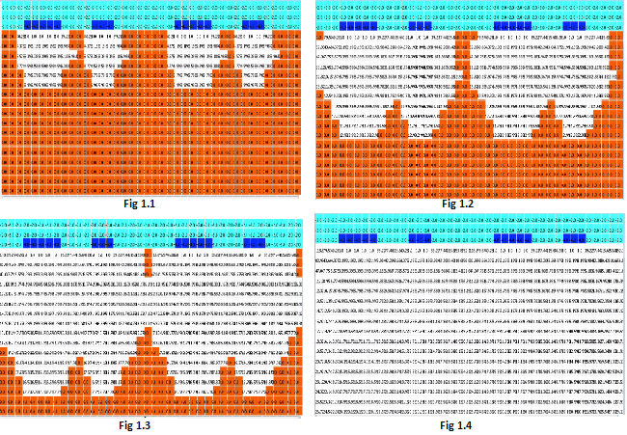

This Paper model focuses on Uniform corrosion formation pattern in which whenever metal comes with contact favorable corrosion conditions. In Assignment 2 a pit formation takes place. Corrosion formation is truly unpredictable but simulations shows that uniform corrosion provide high degree of damage to the metal.

Experiment 2 Results:-

This model shows the impact of moisture and water on painted metal surface. As we can see that if metal is completely protected it is safe from corrosion. Thus this simulation end in 4 second when water reaches the surface and no change happens after that.

Experiment 3 Results: -



This model provides the interesting result. We had seen that when metal is exposed to environment it takes 20 simulation seconds to corrode but when painted metal surface which has a crack is flown by water and then corrosion start still takes longer time as compared to fully exposed surface. This simulation runs for 1 min 39 Seconds.

Experiment 4 Results:-



This model shows when there is high amount of water inlet over the exposed surface. As the conditions are brutal thus it corrode as faster rate when compared to painted surface and painted surface which has a crack. On the other hand in experiment 1 whole surface is flooded with water thus that one corrode even faster at 60 simulation seconds.

**Experiment 5 Results :-**



This Model Shows the passivation process and shows how the corrosion stops after the sometime due to formation of metal oxide protective layer.

1. **CONCLUSIONS :-**

“The word corrode is derived from the Latin corrodere, which means “to gnaw to pieces.” The general definition of corrode is to eat into or wear away gradually, as if by gnawing.” REF 6.1

Corrosion is a broad term which explains the degradation. It can be a metal, plastic etc.

This paper focus on corrosion of a metal and simulation of the same using cell-devs CD++ New version along with Lopez simulator which is a excellent tool providing new features such as multiple input variable and state variable for a single Atomic cell. In previous version in order to give multiple values to same cell one has to create multiple dimensions/layers.

Metals being the important part of infrastructure need to be protected for the higher utilization and long life. We created several set of experiments to show the corrosion of the metals under various circumstances using inertial delay.

It is noted that when metal even has crack it take time to water and oxygen to penetrate and thus to start the corrosion.

It was seen that when metal is fully exposed to brutal environment conditions it get corroded away easily. However when metal is protected with layer of insulation and if its maintained properly then it extends the life and preserve the strength.

Passivation is a process when corrosion stops due to formation of metal oxide over the corroded part of metal thus stops the corrosion and creates a pit like formation. This Oxide is produced with rust deposition. Experiment 5 results Shows such a output.

Although passivation stops the corrosion after some time but still creates the substantial damage.

In order to reduce the corrosion some metals are also painted with metal oxide layer so that metal is not corroded away. As metal oxide comes in contact with environment and metal is protected.Thus passivation is also helpful to save the metal if coating is applied.

1. **REFERENCES :-**
2. “The Effects and Economic Impact of Corrosion” from ASM International (<https://www.asminternational.org/documents/10192/1849770/06691G_Chapter_1.pdf>)
3. “Methodologies for Discrete-Event Modelling and Simulation” Course Slides.
4. “The DEVS Formalism” by Rhys Goldstein, Gabriel A. Wainer, Azam Khan
5. “Cellular automata approach to corrosion and passivity phenomena” by Łukasz Bartosik1, Dung di Caprio, and Janusz Stafiej.